**Day 5 Testing Error Handeling And Beckened Integration Refinement**

**Steps for implementation**

**01 Functional Testing**

**Everything is working good on my e commerce website.**

**All API of products working Excellently.**

**Showing status of API on thunder client**

**Thunder client: for mock API testing**



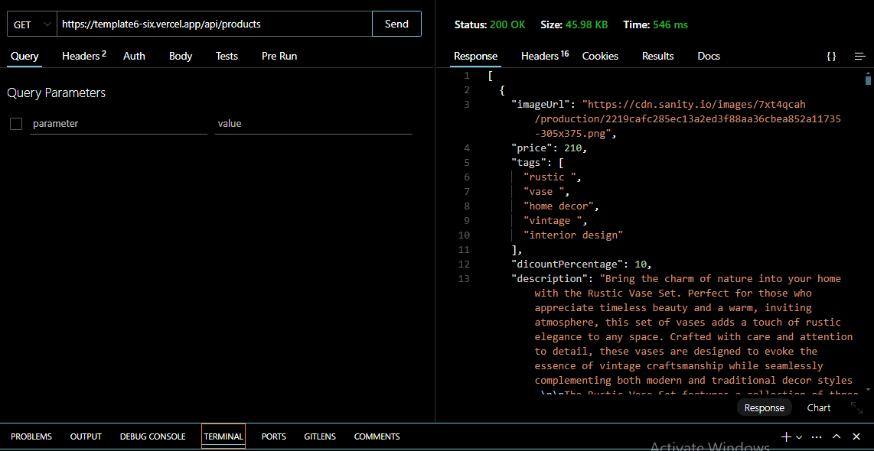

**All data from import API fetching from sanity on frontened nicely. Like images, description, price, discount, tags, etc showing on sanity products schemas**

**There are four schemas**

* **Products schema**
* **producList schema**
* **order schema**
* **category schema**

**04 : Performance Optimization**

**My e-commerce website of clothing is working in mobile laptop and computer screen and it is fully responsive . Developer resources , performance monitor showing here**

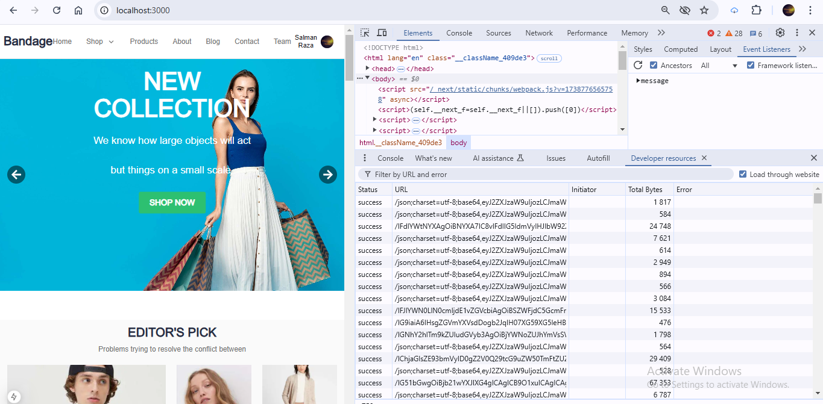

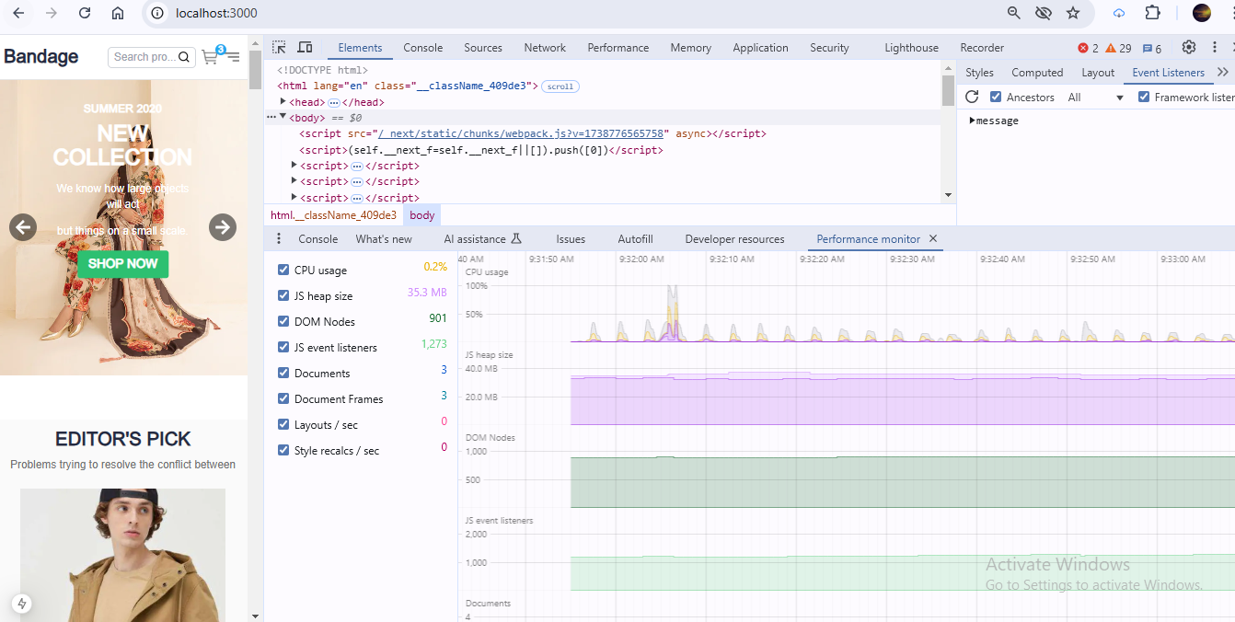

**Image issues**

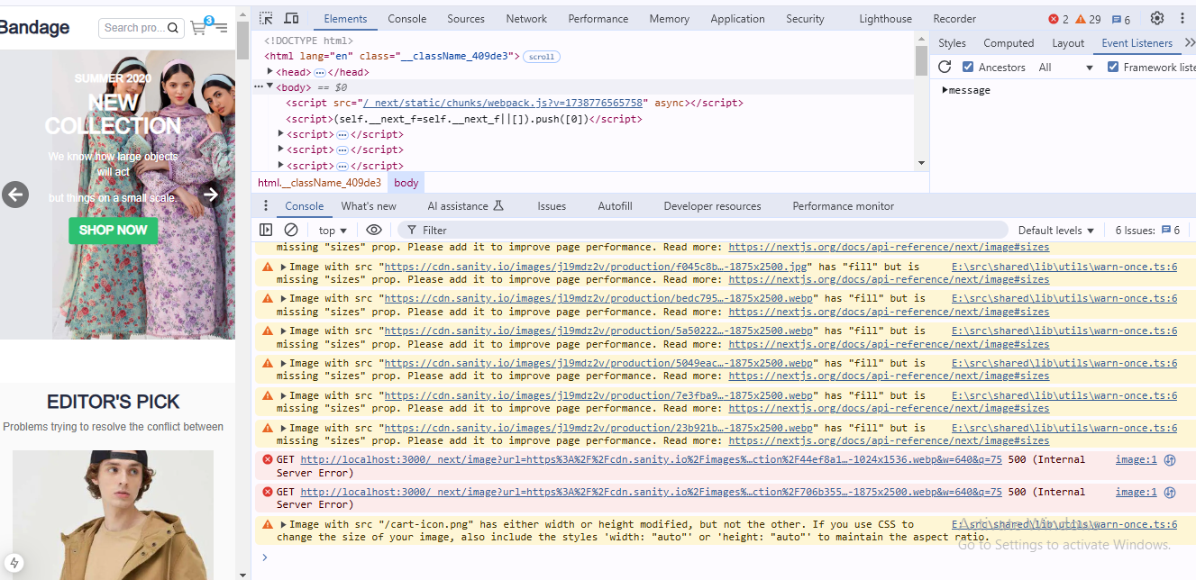

**All data of products fetching from sanity perfectly**

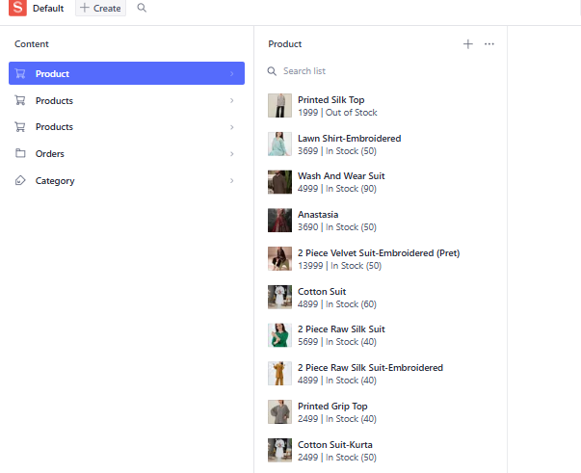

**And add to cart functionality is applied on every products**

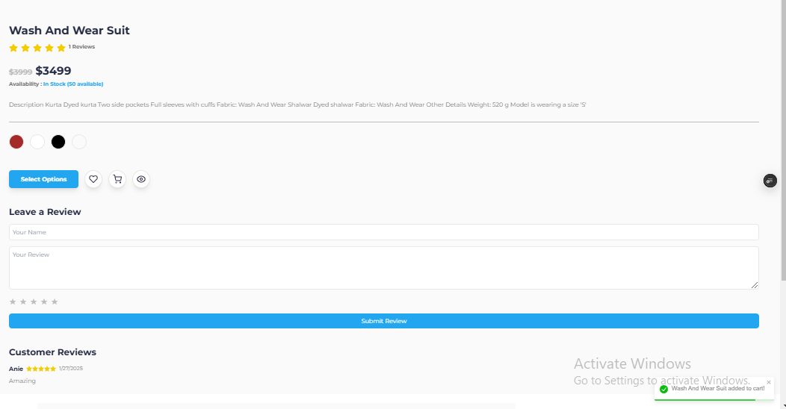

**On clicking every products are opening dynamically in page having environment of add to cart functionality**

**Cart functionality is working perfectly on clicking showing ui of addition and minus products and total calculation price of products**

**Loading page is working perfectly**

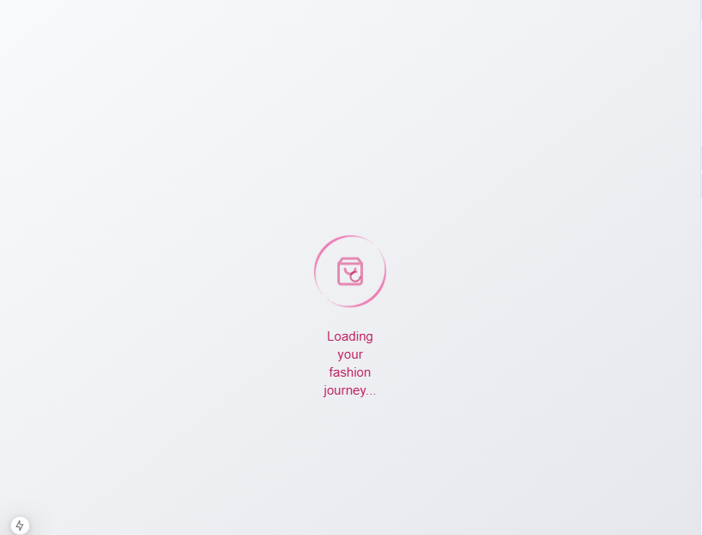

**Categories Products are displayed correctly**

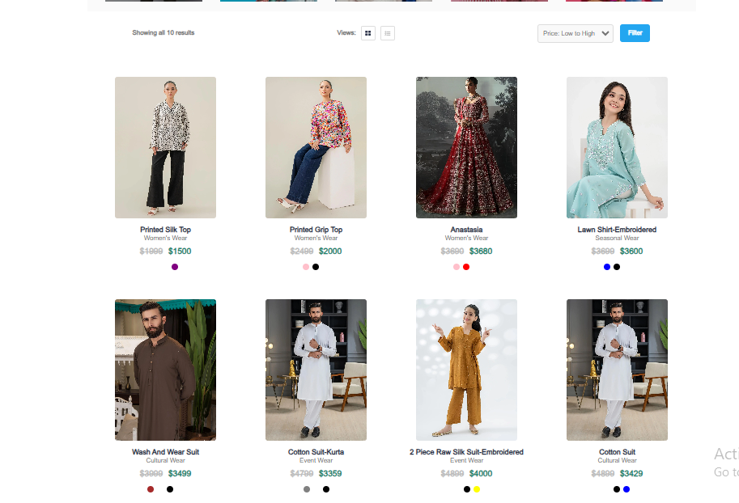

**Filter and search: validate accurate on user validation**

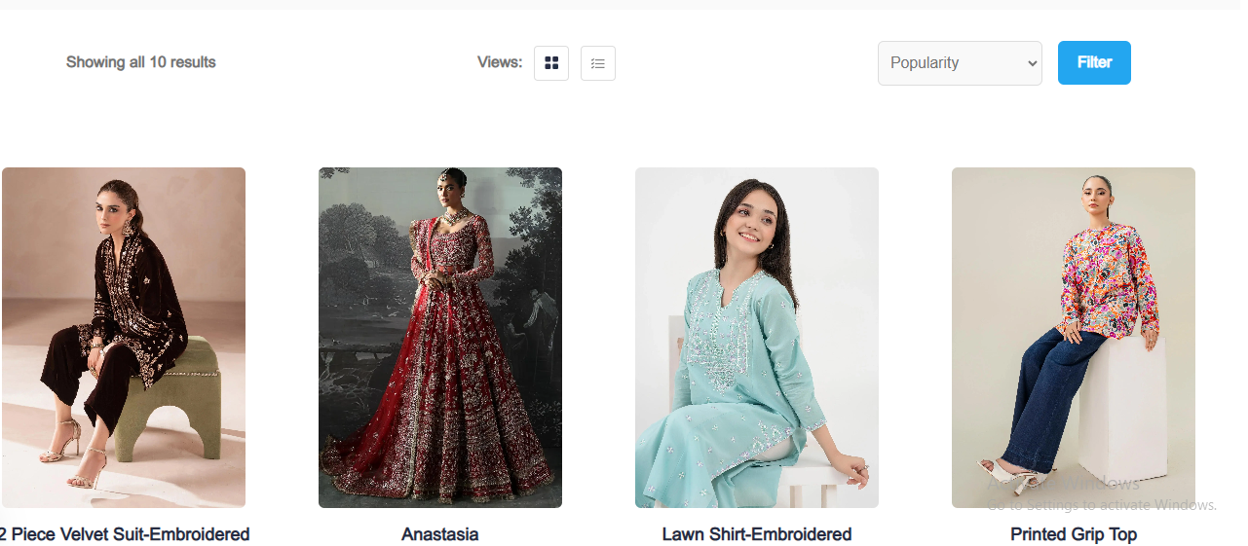

**Cart operation : Add update remove item from cart**

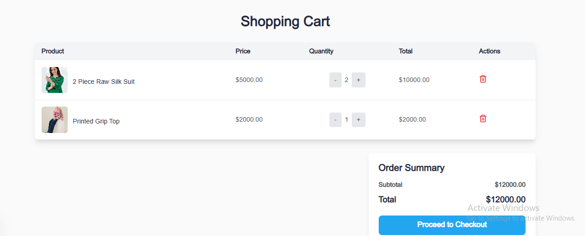

**Dynamic Routing : verified individual product detail pages load currently**

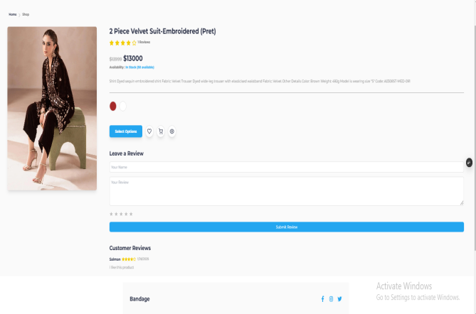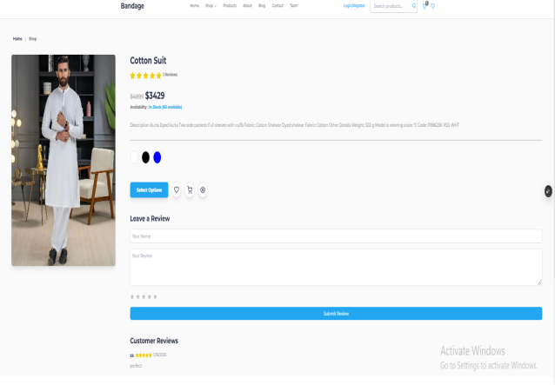

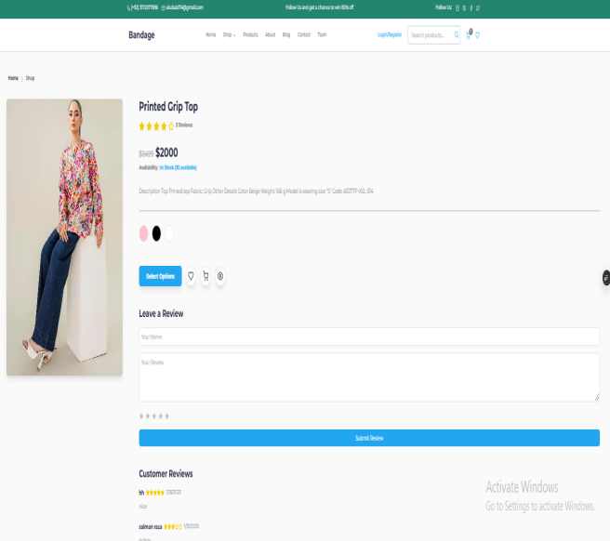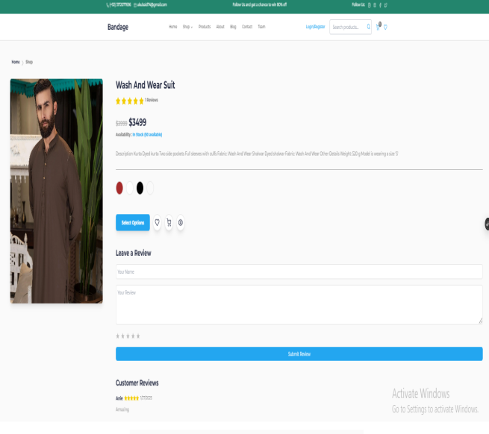

**Testing tools:**

**Postman: For Mock API testing**

**Error Handling:**

**Try catch block has been used For handling API error**

try {

const response = await fetch('https://template6-six.vercel.app/api/products');

if (!response.ok) {

throw new Error(`HTTP error! Status: ${response.status}`);

}

const products = await response.json();

for (const product of products) {

await uploadProduct(product);

}

} catch (error) {

console.error('Error fetching products:', error);

}

**Here Light House is installed and used to testing and checking my online e commerce platform working correctly**

**Performance Accessibility Best practice seo**

**Npm install –g lighthouse**

**Lighthouse** [**http://localhost:3000**](http://localhost:3000) **-–view**

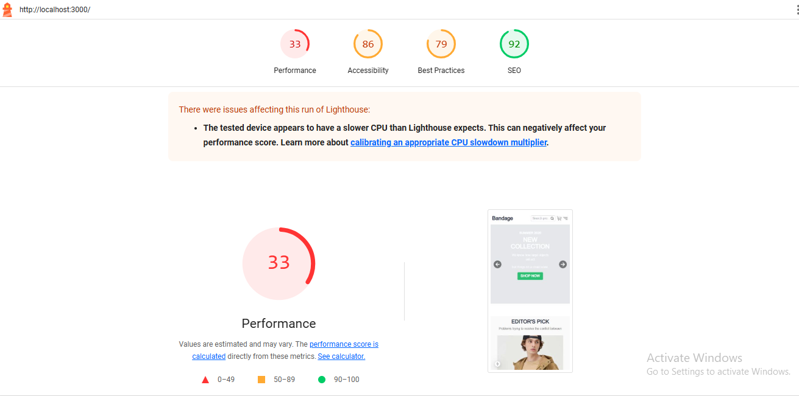

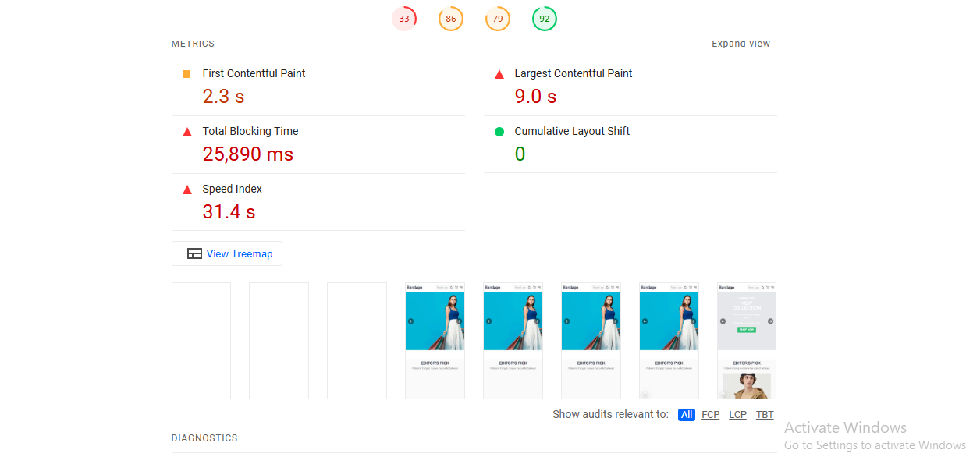

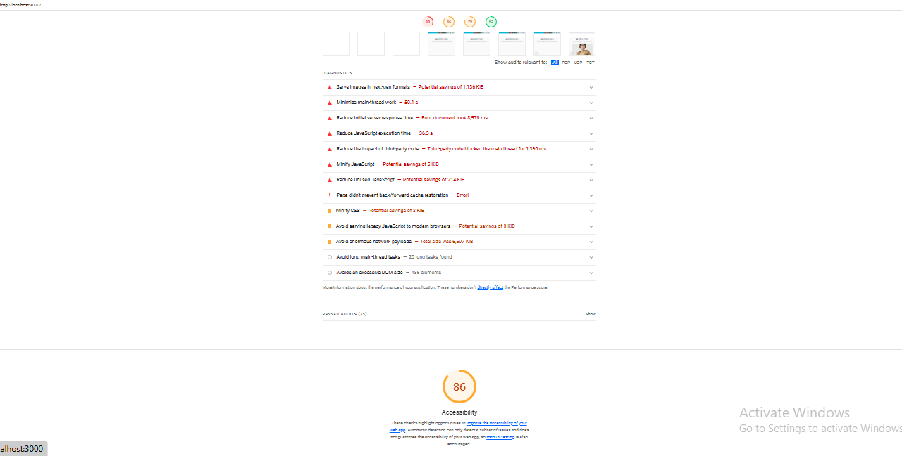

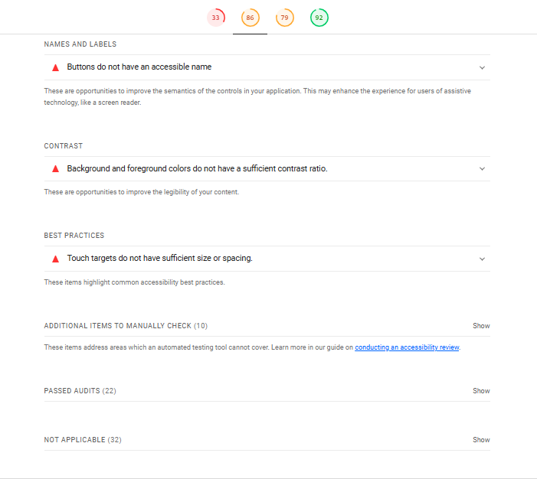

**Testing_Report_Sample.csv**



|  |
| --- |
|  |